How to download and install Oracle Express Edition

1. Google “Oracle Database Express Edition 11*g”*
2. Choose “Oracle Database Express Edition 11*g Release 2”, you will get this page*

*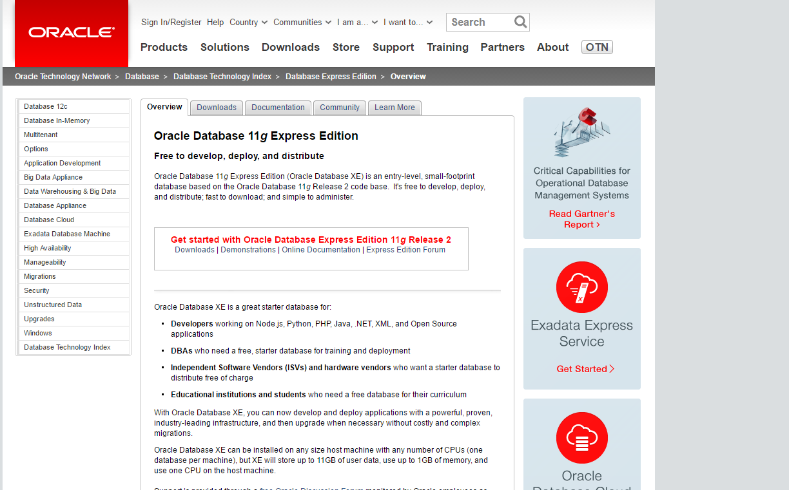*

1. Go to “Downloads” tab and choose the appropriate one for your machine

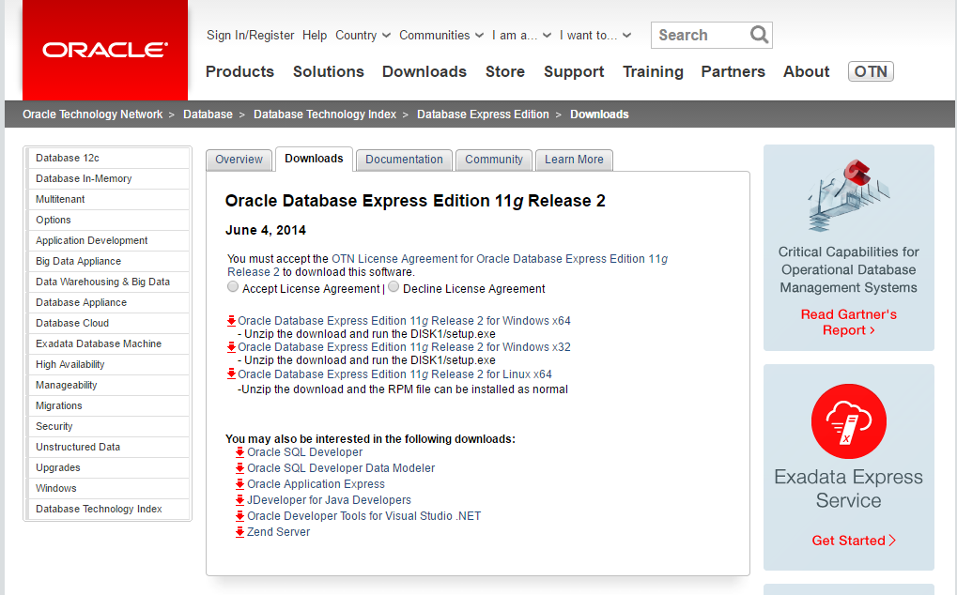

1. After downloading, install. Caution : You will be asked to key in a password for the admin. This password will be used time and time again if you want to conduct admin role to your database. So remember this password. The user id for this password is “system”.
2. 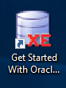You should get this icon on yr desktop
3. Double click on the icon and you will get this :

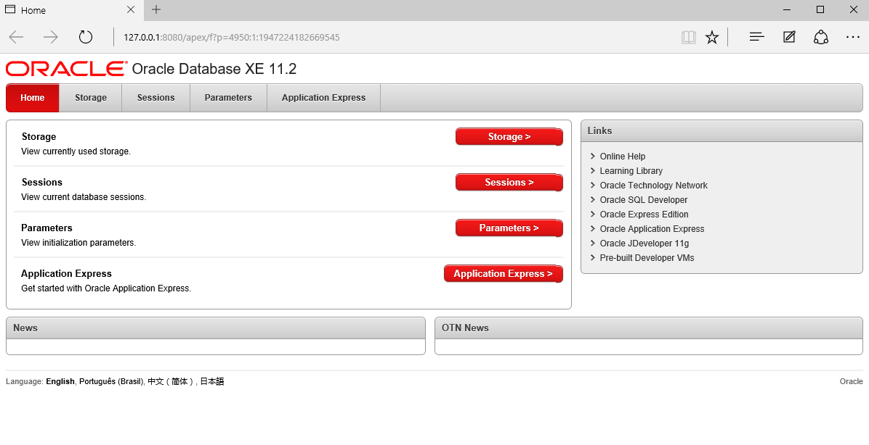

You can get more info here from the documentation provided.

1. From now on, you can follow the Lab notes provided to you using “HR” user.
2. You are responsible to work on your oracle practices on your own, but you are required to work on the following practices durin Lab sessions:

Practice 1, 6 and 8

1. You are required to SUMBIT the following practices to spectrum for assessment:

Practice 2, 5 and 9

You have to save your SQL queries for each question in a word file, and submit one file for each practice.